# Packages

* eclox.zip : doxgen plugin in eclipse, generate documentation of source files.
* graphviz : generate c/c++ code structural graphs.
* hhc.exe : generate one chm file from html files.

They all can obtain in “G:\R&D\2018\Jerry Hua\002-Doxgen Install\”.

# Install Steps

* You also can download eclox from [**https://anb0s.github.io/eclox/**](https://anb0s.github.io/eclox/) , and extract zip file to local path.
* In Eclipse, use the menu ”Help => Install New Software” and point to the directory where you have extracted the file as follow picture. (In ”Work with” type such as：eclox - file:/C:/Users/anb0s-eclox-a7d7762/).
* After success installation, the @ icon will display in eclipse.

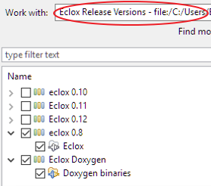 

* Create new doxgen configuration file. In eclipse, use menu ”File => New => Other.. Doxyfile.”

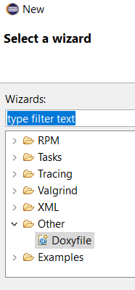

* Basic configuration shows in the following picture:

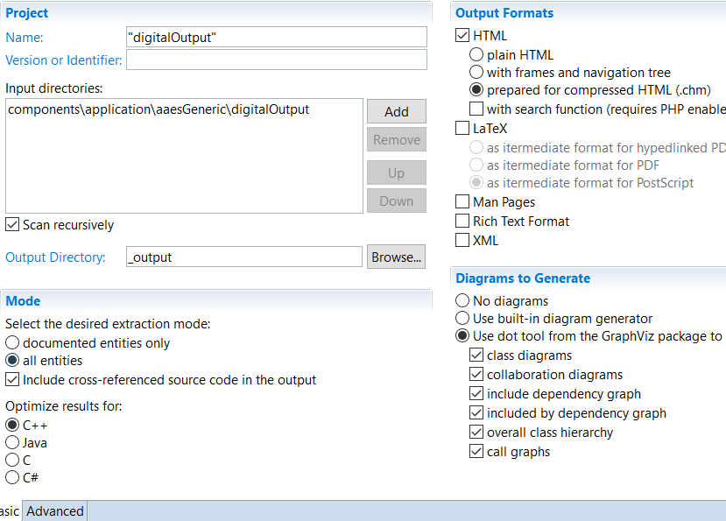

Choose the ”Output Directory” as you like.

* Advanced configuration: Dot path, browse your graphviz\bin path. (such as “C:\mbs\programs\graphviz\bin”)

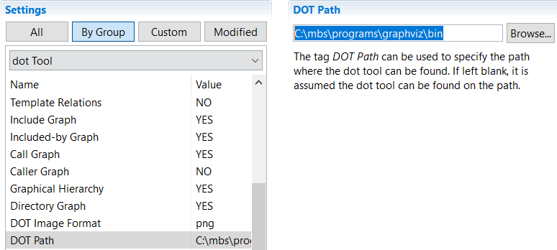

* Advanced configuration: hhc.exe path, browse your hhc.exe path. (such as “C:\mbs\programs\htmlhelp”)

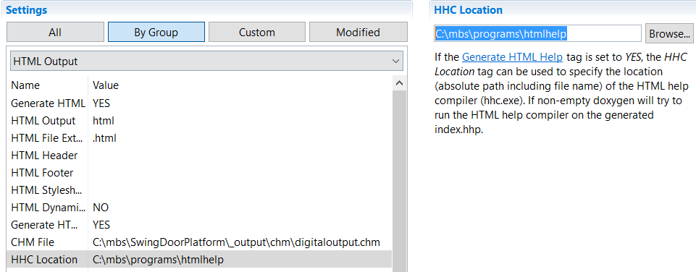

Assign the ”CHM file” *Path* and *Name*, the *Path* should not same as *.html file path.

* Save doxyfile. Then can click  to run doxgen.